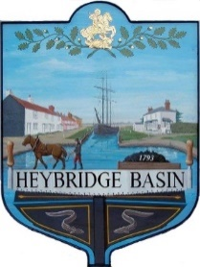
HEYBRIDGE BASIN PARISH COUNCIL
Donation Application Form

1. | Name of the group or organisation in full:
2. | A short description of aims of the group or organisation:
3. | Contact Details:  Name and position in the group/organisation:  Tel no:  Email:  Correspondence address:
4. | Registered charity number (where applicable):
5. | What will the donation be used for:
6. | Total cost of project/items:
7. | Amount of donation requested:
8. | When are the funds required:
9. | When will the money be spent:
10. | If the total cost of the project/items is more than the donation, how will the rest be financed:
11. | Who will benefit from the project/items:
12. | Approximately how many of those people who will benefit are residents of Heybridge Basin:
13. | Should your application be successful, please provide bank/cheque details for payment to be made:
Please use a separate sheet of paper to submit any other information which you feel will support this application.

Signed…………………………………………………………………. Date……………………………………………

Please return your completed form to the Parish Clerk via post or email to:
HBPC, PO Box 13224, Maldon, CM9 9FW Clerk@heybridgebasinpc.org.uk

